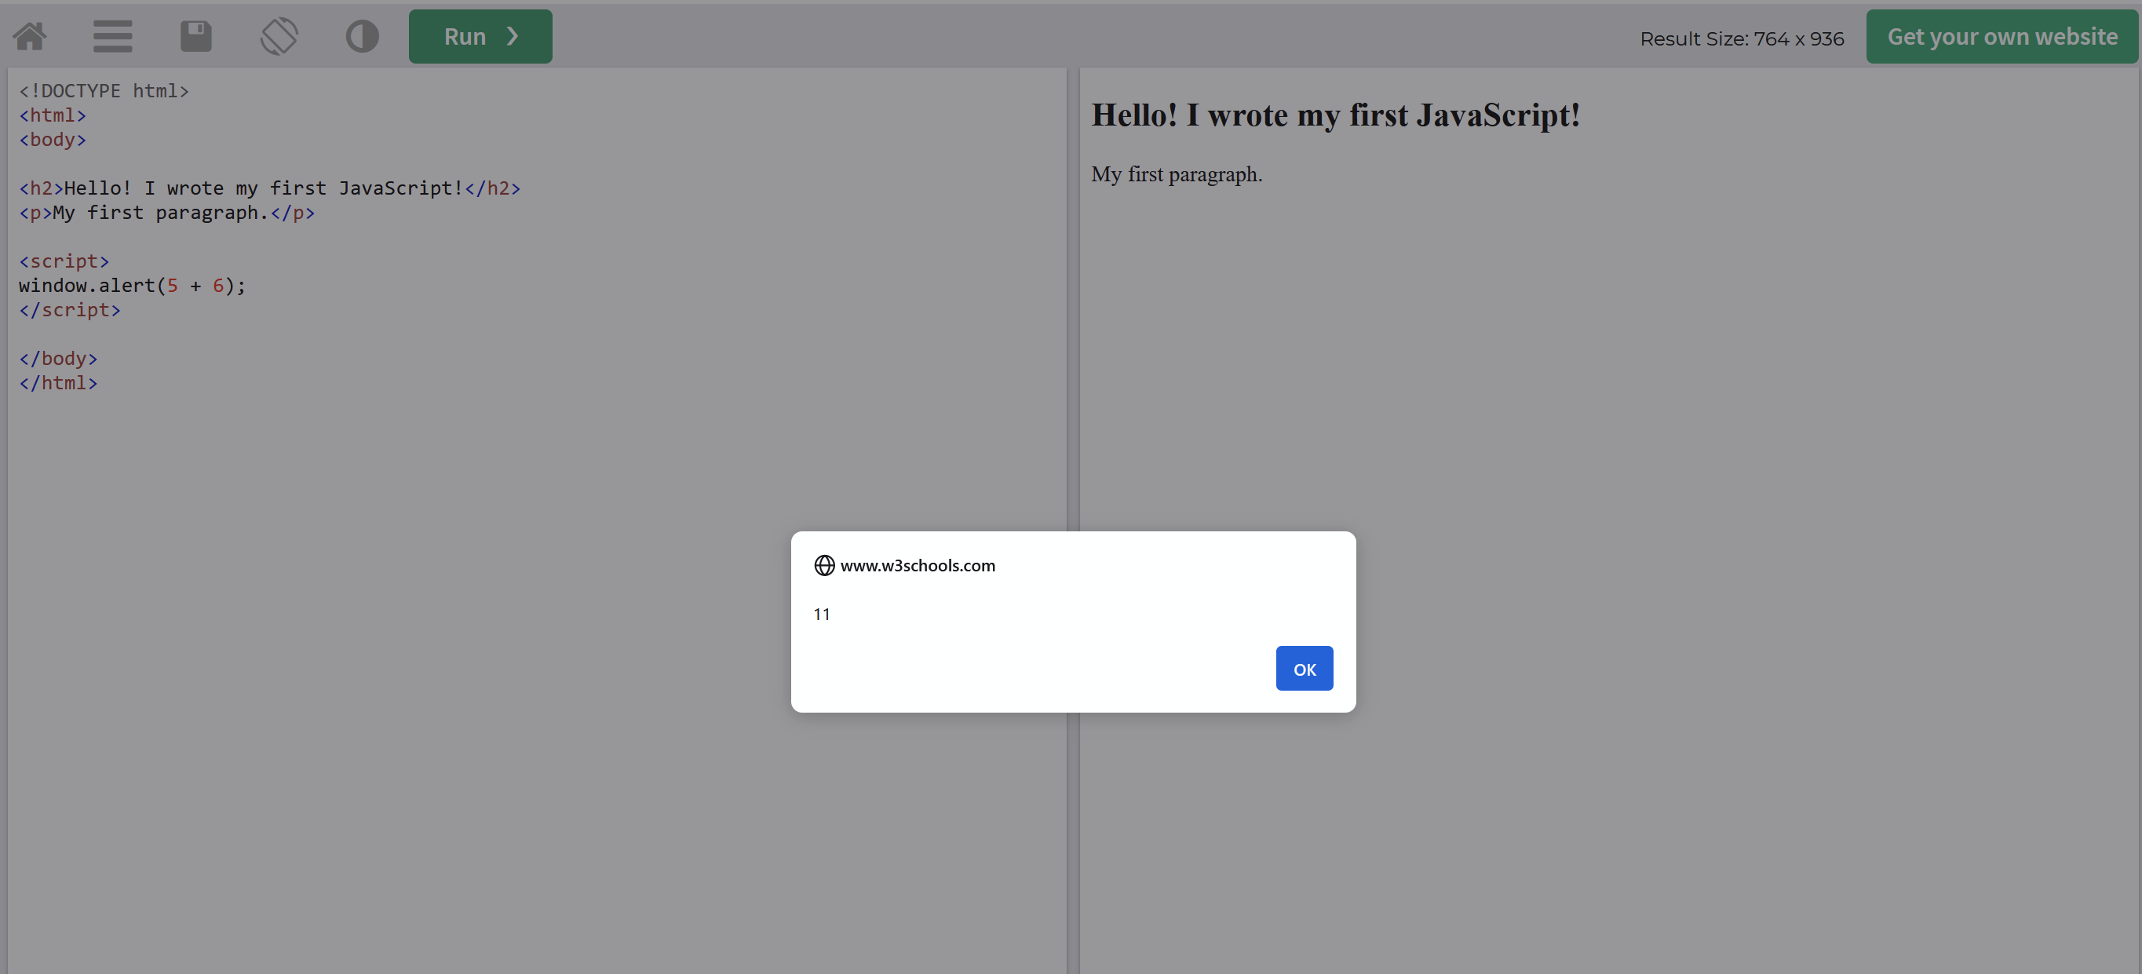

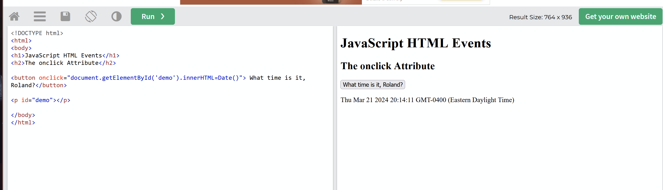

When the button is clicked the time displays below the button.

innerHTML=Date()

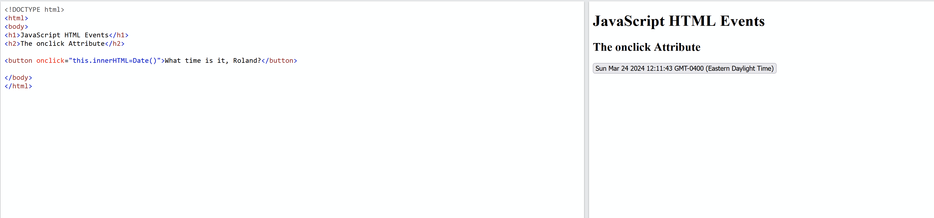When the button is clicked the time displays on the button

This.innerHTML=Date()

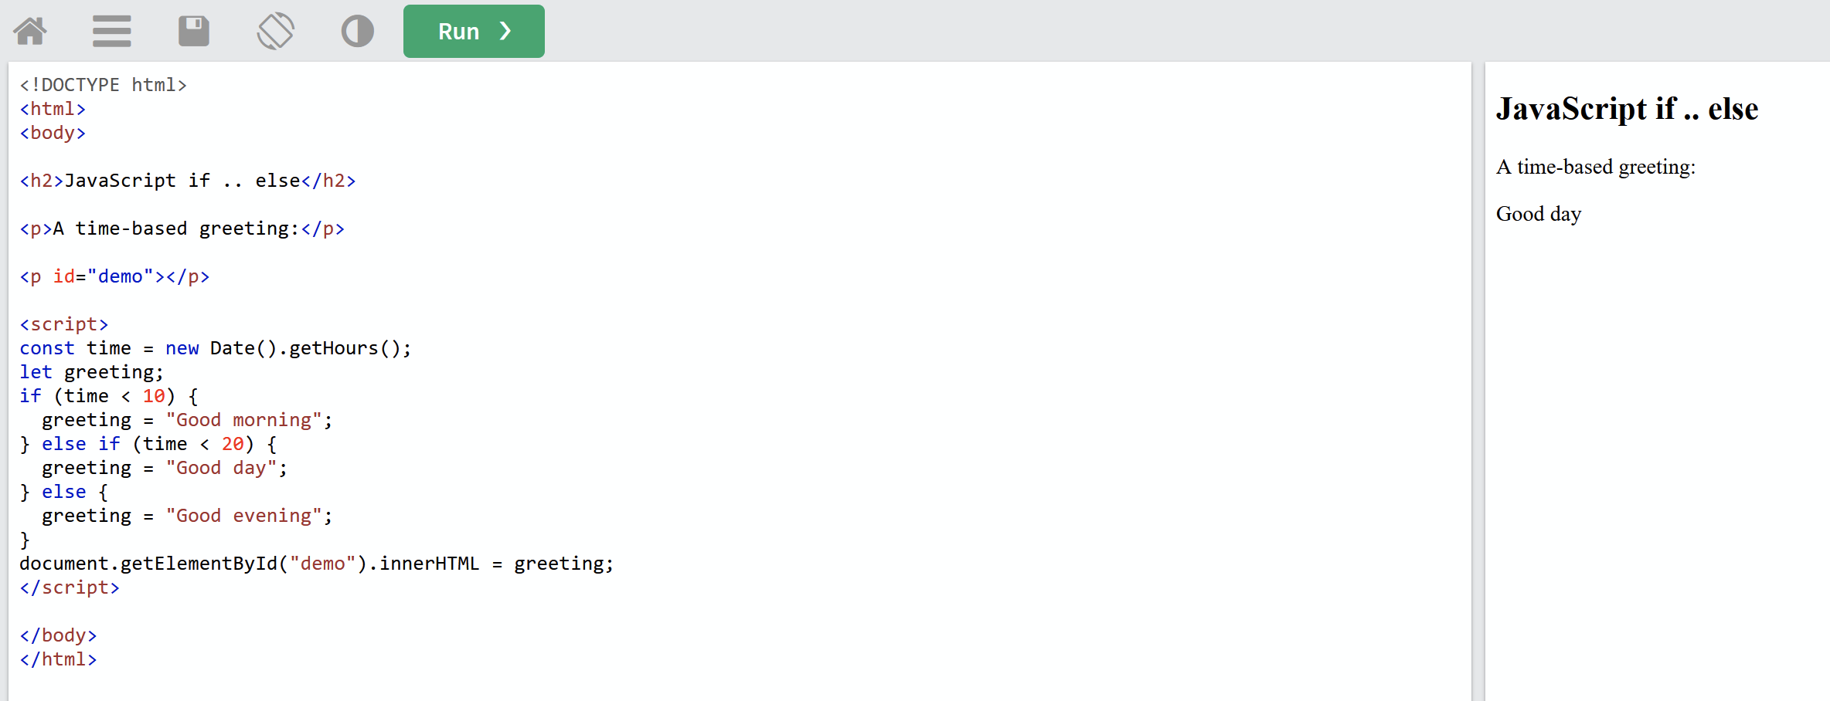

**Else if** has the best control structure when it has multiple conditions to check.